**NunoErin Pong - Overview**

**General Notes**

1. Resolution: 1080P
2. Primary display size is 24” screen / it will also be shown on larger screens (probably about 42”)
3. Prepare for both landscape and portrait orientation

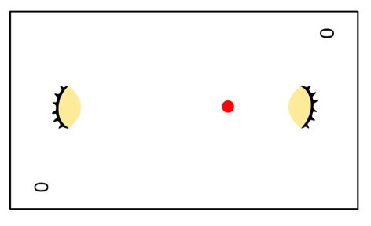 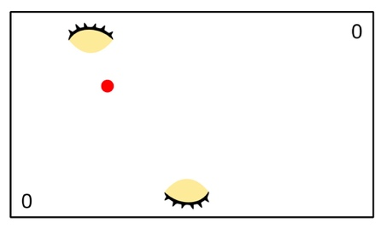

1. If the user clicks the “house” icon in the lower right, exit the application. (The house isn’t shown in all of the drawings below, but it should be visible on all of the pages)

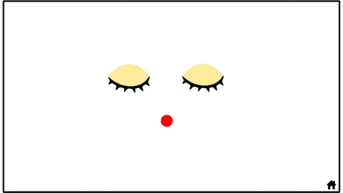

1. If two sequential points are scored without the system registering a touch to the game surface, exit the application.
2. If there is subtle functionality that we haven’t outlined, please implement in the way you think would be most compelling!
3. The graphics we are sending are placeholders. We’d like to run the final images through Yonis’ vector algorithm when it is ready.

**Pong - Home Page**

1. When user selects “Pong” game to play, open to Pong Home page
2. Purpose of Pong homepage is to give a “fanciful and human introduction” to the game. Introduction Functionality follows:
3. Show closed eyes with red ball (as face)
4. Blink eyes several times, end on closed eyes
   1. Beginning / Ending Image

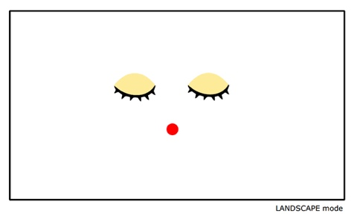

* 1. Reference image of blinking

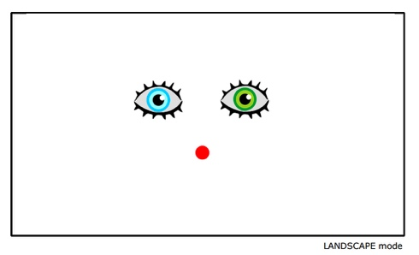

1. After Blinking, slide each eye to the edge, and rotate 90 degrees into position to play (the eye functions as the pong paddle)
   1. Reference image - closed eyes slide to edge. Hold for a fraction for a second (or in a way people can see the new face)

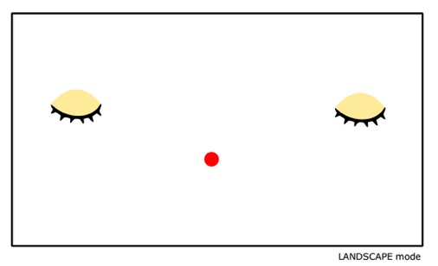

* 1. Reference image - for rotating eyes into position, red dot disappears 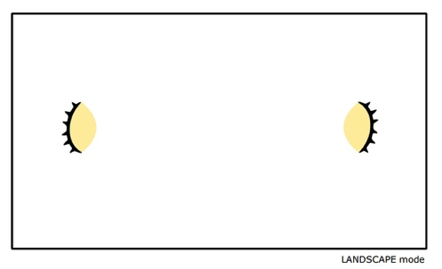

**Pong - Game**

1. After the introduction, add the score of 0,0 to the game.
   1. Reference - grid shows game boundaries and slide area for eye paddle.

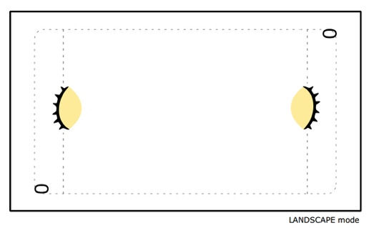

1. Show the Ball
   1. Please make the ball appear in a way you think is interesting.

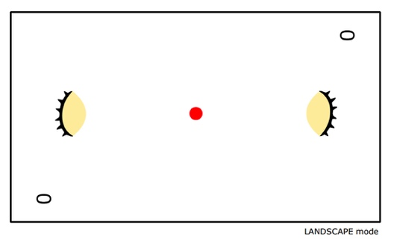

1. Begin Game – ball rolls to one player
   1. Please follow your experience and intuition in determining how this works. (For Example, you mentioned having a short delay. Please implement in a way that you think is elegant and easy to understand.
   2. Please use speed of 7 or 8 (based on your game) so it is fast enough to be fun, but not too fast for kids)
   3. Player slides Closed Eye (paddle) left or right. Finger does not have to be on top of eye to slide. Finger can be behind eye and still move.

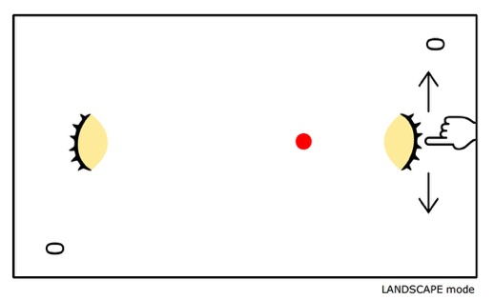

* 1. When ball and eye collides, blink eye once. Then close eye again.

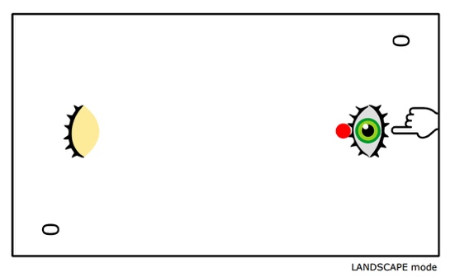

1. Score
   1. When player scores, update score, one point per goal
   2. Player Winner feedback
      1. Winners eyes blink a few times, then closes, update score

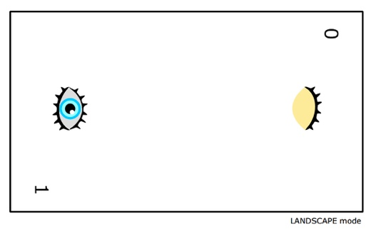

* + 1. Afterwards, Loosing eye sheds two tears

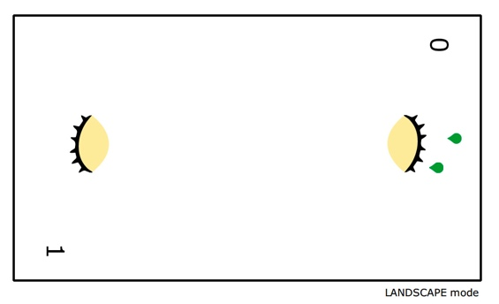

1. Start next point
   1. repeat from step 2
   2. Ball rolls in direction of the winner
2. Win the the game
   1. First player to reach 10 points wins the game (We don’t know if it will that is too short, too long, or just right. If you have a different recommendation, please let us know! Would welcome your suggestions.
3. Game Winner Feedback
   1. We don’t know yet. We’d like to see how the winner feedback for each point looks and then decide. We’re open to any thoughts or ideas you have, too.
4. When game ends,
   1. After the winner feedback is presented, we thinking to show an icon that says, “Rematch”. Show it at full opacity first, but gradually disappear over a few seconds. If it is touched before it disappears, restart the game. If it is not touched, exit the application. We need to determine a graphic for this though.